|  |  |
| --- | --- |
| **Team No: 592719** | |
| **Project: Jungle Detectives: AI-Powered Image Classification of Wild Big Cats** | |
| **Aditya Raj Srivastava** | **Anshuman Biswal** |
| **Gaurav Sharma** | **Yash Rajesh Akolu** |

**Project Report Format**

**1. INTRODUCTION**

1.1 Project Overview

1.2 Purpose

**2. LITERATURE SURVEY**

2.1 Existing problem

2.2 References

2.3 Problem Statement Definition

**3. IDEATION & PROPOSED SOLUTION**

3.1 Empathy Map Canvas

3.2 Ideation & Brainstorming

**4.** **REQUIREMENT ANALYSIS**

4.1 Functional requirement

4.2 Non-Functional requirements

**5. PROJECT DESIGN**

5.1 Data Flow Diagrams & User Stories

5.2 Solution Architecture

**6. PROJECT PLANNING & SCHEDULING**

6.1 Technical Architecture

6.2 Sprint Planning & Estimation

6.3 Sprint Delivery Schedule

**7. CODING & SOLUTIONING (Explain the features added in the project along with code)**

7.1 Feature 1

7.2 Feature 2

**8. PERFORMANCE TESTING**

8.1 Performace Metrics

**9. RESULTS**

9.1 Output Screenshots

**10. ADVANTAGES & DISADVANTAGES**

**11. CONCLUSION**

**12. FUTURE SCOPE**

**13. APPENDIX**

**1. INTRODUCTION**

**1.1 Project Overview: Jungle Detectives - AI-Powered Image Classification of Wild Big Cats**

In the realm of conservation and wildlife exploration, the project "Jungle Detectives" stands as a beacon of technological innovation. This initiative, titled "Jungle Detectives: AI-Powered Image Classification of Wild Big Cats," harnesses the power of advanced machine learning and computer vision to safeguard the majestic big cat species that roam our planet.

**Project Vision:**

Our vision is to revolutionize wildlife monitoring and conservation efforts by employing cutting-edge AI techniques. By focusing on big cats – from the iconic Bengal tiger to the elusive snow leopard – our project seeks to enhance the understanding, appreciation, and protection of these magnificent creatures.

**Project Features:**

1. Intelligent Image Classification: Using state-of-the-art deep learning algorithms, the project enables accurate identification and classification of ten distinct big cat species from images.

2. User-Friendly Interface: The intuitive web interface allows users to effortlessly upload images, preview them, and submit for classification, ensuring a seamless experience for wildlife enthusiasts, rangers, and tourists.

3. Real-Time Predictions: Leveraging a Flask backend and a responsive frontend, the system provides real-time predictions, empowering forest rangers and safari tourists with immediate information about the big cats they encounter.

4. Professional Design: The web application boasts a professional and visually appealing design, enhancing user engagement and ensuring a positive interaction with the AI-powered classification system.

5. Technological Backbone: The project utilizes a three-tier architecture and microservices, combined with popular deep learning frameworks like TensorFlow and ResNet50, guaranteeing robustness, scalability, and efficiency.

**1.2 Purpose:**

**Social Impact:**

- Wildlife Conservation: By aiding in accurate big cat identification, the project contributes significantly to wildlife conservation efforts, supporting the protection of endangered species.

- Education and Awareness: Jungle Detectives fosters awareness among safari tourists, nature enthusiasts, and the general public, promoting understanding and respect for the natural world.

- Empowering Rangers: Forest rangers equipped with this tool can ensure the safety of tourists and enhance their conservation efforts, making a substantial impact on preserving biodiversity.

**2. LITERATURE SURVEY:**

**2.1 Existing problem:**

"Inaccurate Big Cat Species Identification: A Challenge for Forest Rangers and Safari Tourists."

**2.2 References:**

1. When researchers enter an unknown location/forest, they have difficulty in identifying the native wild specie of that area.
2. People on treks and safaris often don't know the wildlife species that they have encountered and hence have no knowledge on how to act around it.
3. Forest rangers have to mannually travel, locate and identify species living in that area.
4. Hear of people getting attacked when they encounter animals and approach them without having knowledge of the species.
5. Hear of scientists and researchers having to plan another expedition as they missed to identify a new species and mistook it for an existing one..
6. Hear of forest rangers going on rounds to identify species physically despite the weather conditions

**2.3 Problem Statement Definition**

Forest rangers and safari tourists often encounter wild big cats during their expeditions. Accurate identification of these species is crucial for both the safety of tourists and the conservation efforts of rangers. However, the current methods of identifying big cat species, particularly in the wild and diverse environments of natural habitats, are often error-prone and time-consuming. Rangers need a quick and reliable way to identify species to ensure the safety of tourists and to document wildlife for conservation purposes. Similarly, tourists seek an immersive experience but lack the means to confidently identify the species they encounter.

**Objectives:**

1. Real-time Identification: Develop a system capable of real-time big cat species identification from images or video footage captured during forest expeditions and safari tours.

2. Accuracy and Reliability: Ensure the system provides highly accurate and reliable identification results, allowing forest rangers to make informed decisions regarding safety protocols and tourists to engage more deeply with the wildlife experience.

3. User-Friendly Interface: Create a user-friendly mobile application or device that is intuitive and accessible for both forest rangers and safari tourists, enabling them to easily capture and identify big cat species.

4. Offline Capabilities: Design the system to work offline, considering that many natural habitats lack consistent internet connectivity, ensuring its functionality even in remote locations.

5. Educational Integration: Integrate educational features within the application to provide tourists with informative content about the identified species, enhancing their understanding and appreciation of wildlife.

6. Collaborative Data Collection: Enable forest rangers to contribute to conservation efforts by allowing them to upload identified species data to a centralized database, aiding wildlife researchers in their studies.

By addressing these objectives, the project aims to empower forest rangers and safari tourists with a reliable and user-friendly tool for quick, accurate, and educational big cat species identification. This solution not only enhances the safety of tourists but also contributes valuable data to ongoing conservation initiatives, fostering a deeper connection between humans and the wildlife they encounter.

**3. IDEATION & PROPOSED SOLUTION**

**3.1 Empathy Map Canvas:**

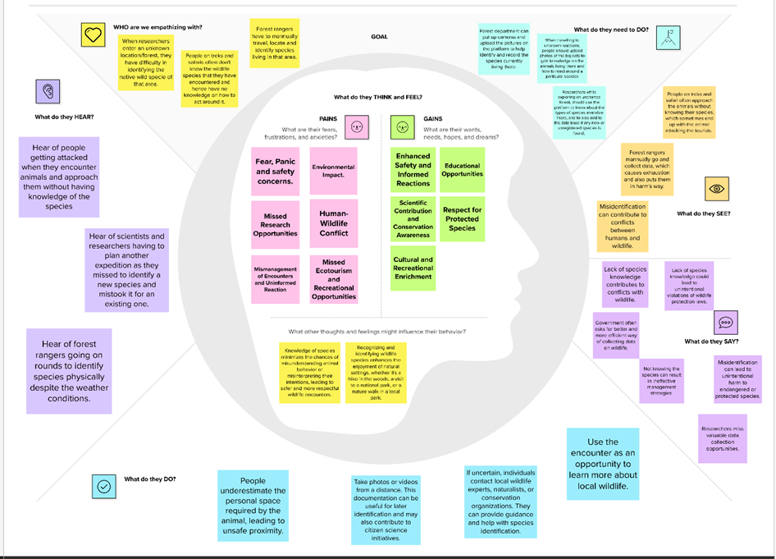

**3.2 Ideation & Brainstorming:**

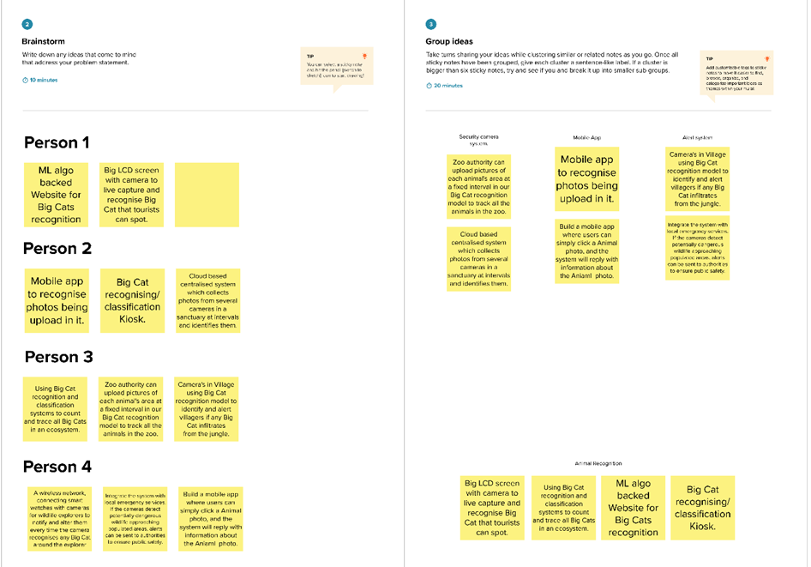

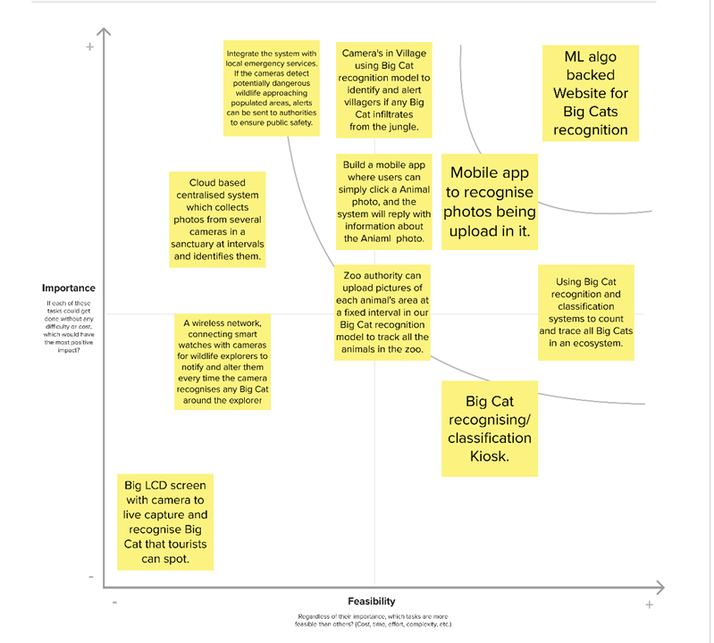

**4.** **REQUIREMENT ANALYSIS**

**4.1 Functional requirement:**

1. HTML, CSS, JavaScript
2. Python Application and its Libraries
3. Kaggle
4. Image Recognition Model
5. ResNet50
6. TensorFlow
7. Flask
8. VGG16

**4.2 Non-Functional requirements:**

1. Performance: The system must provide quick and accurate classifications, ensuring low latency in processing user requests.
2. Usability: The user interface must be intuitive and easy to navigate, catering to users with varying levels of technical expertise.
3. Reliability: The system should be available 24/7, with minimal downtime for maintenance or updates.
4. Scalability: The architecture and algorithms must be scalable to accommodate an increasing number of users and images over time.
5. Accuracy: The image classification model must achieve a high accuracy rate in identifying big cat species.
6. Security: The system must employ robust security measures to protect user data, uploaded images, and prevent unauthorized access.
7. Compliance: The project must adhere to legal and ethical standards related to data privacy and wildlife conservation regulations.
8. Documentation: Comprehensive documentation, including user guides and technical manuals, must be available for users and developers.
9. Interoperability: The system should be compatible with various web browsers and devices, ensuring a seamless experience for users across platforms.
10. Maintainability: The codebase and infrastructure should be well-organized, allowing for easy maintenance, updates, and future enhancements.

**5. PROJECT DESIGN:**

**5.1 Data Flow Diagrams & User Stories**

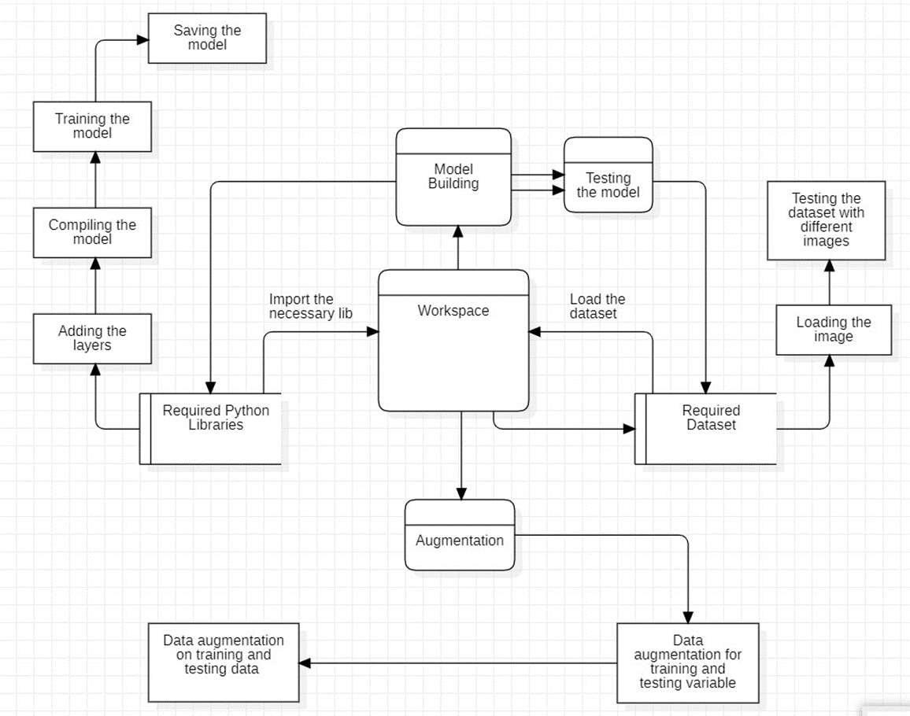

|  |  |  |  |  |  |  |
| --- | --- | --- | --- | --- | --- | --- |
| **User Type** | **Functional**  **Requirement (Epic)** | **User Story**  **Number** | **User Story / Task** | **Acceptance criteria** | **Priority** | **Release** |
| Customer  (Mobile App user) | Registration | USN-1 | As a user, I can register for the application by entering my email, password, and confirming my password. | I can access my account / dashboard | High | Sprint-1 |
|  |  | USN-2 | As a user, I will receive confirmation email once I have registered for the application | I can receive confirmation email & click confirm | High | Sprint-1 |
|  |  | USN-3 | As a user, I can register for the application through Facebook | I can register & access the dashboard with Facebook Login | Low | Sprint-2 |
|  | Login | USN-4 | As a user, I can log into the application by entering email & password | I can access my account / dashboard and upload image. | High | Sprint-1 |
|  | Dashboard | USN-5 | As a user, I can capture an image and upload it in the application. | I can get the identification of the animal in the image. | High | Sprint-1 |
|  |  | USN-6 | As a user, I can select an image from gallery and upload it in the application. | I can get the identification of the animal in the image. | High | Sprint-2 |
|  | Inference | USN-7 | As a user, I can see the name of the animal in the picture after identification is done. | I can fill the feedback form or upload another image. | High | Sprint-1 |
|  |  | USN-8 | As a user, I can see the information about the animal in the picture after identification is done. | I can fill the feedback form or upload another image. | Medium | Sprint-2 |
|  | | | | | | |
| Customer (Web App user) | Registration | USN-1 | As a user, I can register for the application by entering my email, password, and confirming my password. | I can access my account / dashboard | High | Sprint-1 |
|  |  | USN-2 | As a user, I will receive confirmation email once I have registered for the application | I can receive confirmation email & click confirm | High | Sprint-1 |
|  |  | USN-3 | As a user, I can register for the application through Facebook | I can register & access the dashboard with Facebook Login | Low | Sprint-2 |
|  | Login | USN-4 | As a user, I can log into the application by entering email & password | I can access my account / dashboard and upload image. | High | Sprint-1 |
|  | Dashboard | USN-5 | As a user, I can select an image from gallery and upload it in the application. | I can get the identification of the animal in the image. | High | Sprint-1 |
|  | Inference | USN-6 | As a user, I can see the name of the animal in the picture after identification is done. | I can fill the feedback form or upload another image. | High | Sprint-1 |
|  |  | USN-7 | As a user, I can see the information about the animal in the picture after identification is done. | I can fill the feedback form or upload another image. | Medium | Sprint-2 |
|  | | | | | | |
| Customer Care Executive | Registration | USN-1 | As a CCE, I can register for the application by entering my email, password, and confirming my password. | I can access my account / dashboard | High | Sprint-1 |
|  |  | USN-2 | As a CCE, I will receive confirmation email once I have registered for the application | I can receive confirmation email & click confirm | High | Sprint-1 |
|  | Login | USN-3 | As a CCE, I can log into the application by entering email & password | I can access my account / dashboard and upload image. | High | Sprint-1 |
|  | Dashboard | USN-4 | As a CCE, I can review the feedbacks submitted by the users. | I can view the feedback and take necessary actions. | Medium | Sprint-2 |
|  | | | | | | |
| Administrator | Registration | USN-1 | As an Admin, I can register for the application by entering my email, password, and confirming my password. | I can access my account / dashboard | High | Sprint-1 |
|  |  | USN-2 | As an Admin, I will receive confirmation email once I have registered for the application | I can receive confirmation email & click confirm | High | Sprint-1 |
|  | Login | USN-3 | As an Admin, I can log into the application by entering email & password | I can access my account / dashboard and upload image. | High | Sprint-1 |
|  | Dashboard | USN-4 | As an Admin, I can access the datasets present. | I can update/change the dataset, for scaling the usage. | Medium | Sprint-2 |
|  |  | USN-5 | As an Admin, I can see the Employee and customer details. | I can see the customer and employee activities on the app. | Medium | Sprint-2 |
|  |  | USN-6 | As an Admin, I can alter the ML model of the system. | I can access and change the internal code of the app. | Medium | Sprint-2 |

**5.2 Solution Architecture:**

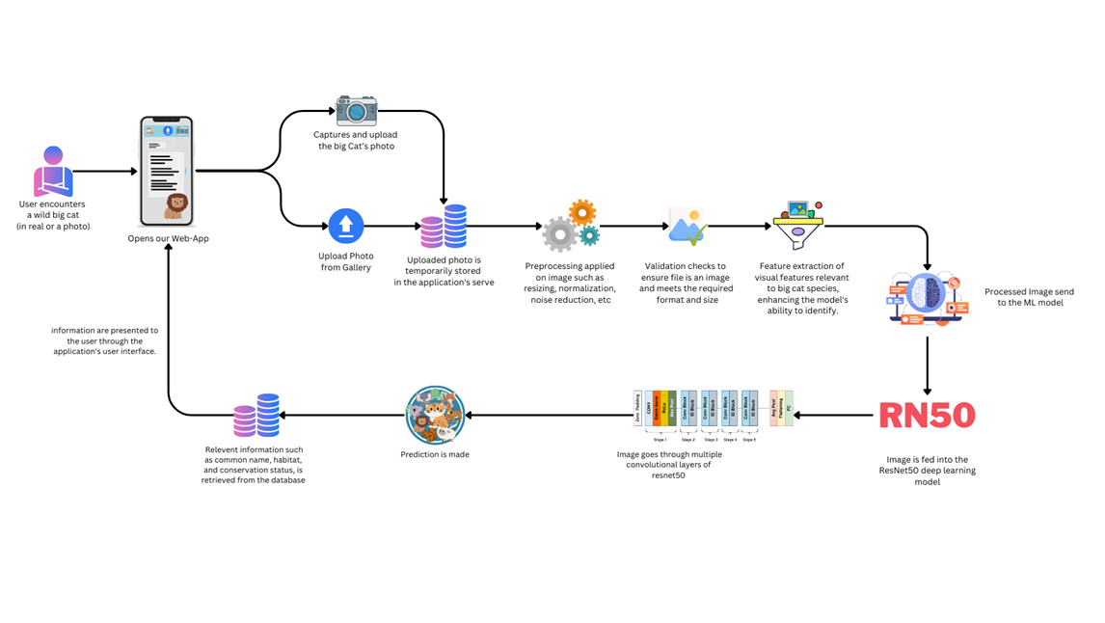

**6. PROJECT PLANNING & SCHEDULING**

**6.1 Technical Architecture:**

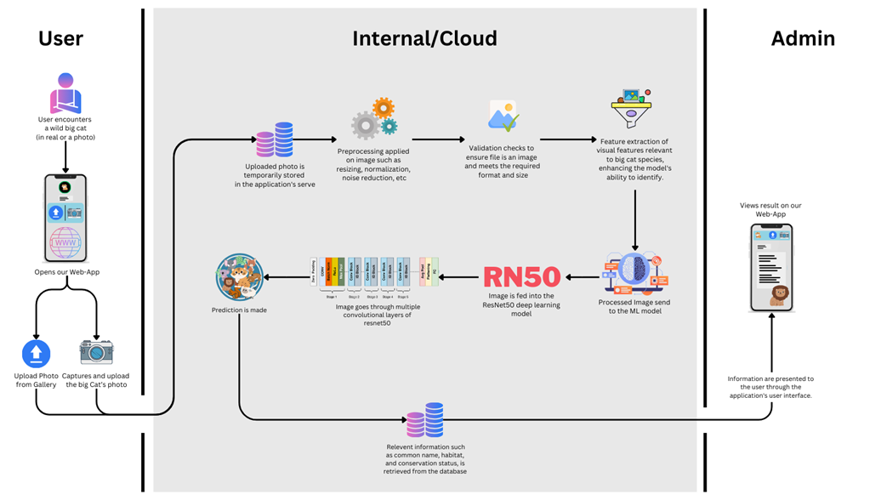

**6.2 Sprint Planning & Estimation:**

|  |  |  |  |  |  |  |
| --- | --- | --- | --- | --- | --- | --- |
| **Sprint** | **Functional**  **Requirement (Epic)** | **User Story**  **Number** | **User Story / Task** | **Story Points** | **Priority** | **Team**  **Members** |
| **Customer (Mobile App user)** | | | | | | |
| Sprint-1 | Registration | USN-1 | As a user, I can register for the application by entering my email, password, and confirming my password. | 5 | High |  |
| Sprint-1 |  | USN-2 | As a user, I will receive confirmation email once I have registered for the application | 4 | High |  |
| Sprint-2 |  | USN-3 | As a user, I can register for the application through Facebook | 2 | Low |  |
| Sprint-1 | Login | USN-4 | As a user, I can log into the application by entering email & password | 4 | High |  |
| Sprint-1 | Dashboard | USN-5 | As a user, I can capture an image and upload it in the application. | 5 | High |  |
| Sprint-2 |  | USN-6 | As a user, I can select an image from gallery and upload it in the application. | 5 | High |  |
| Sprint-1 | Inference | USN-7 | As a user, I can see the name of the animal in the picture after identification is done. | 5 | High |  |
| Sprint -2 |  | USN-8 | As a user, I can see the information about the animal in the picture after identification is done. | 4 | Medium |  |
| Sprint-3 | Feedback | USN-9 | As a user, I can submit my feedback for the application. | 3 | Low |  |
| **Customer (Web App user)** | | | | | | |
| Sprint-1 | Registration | USN-1 | As a user, I can register for the application by entering my email, password, and confirming my password. | 5 | High |  |
| Sprint-1 |  | USN-2 | As a user, I will receive confirmation email once I have registered for the application | 4 | High |  |
| Sprint-2 |  | USN-3 | As a user, I can register for the application through Facebook | 2 | Low |  |
| Sprint-1 | Login | USN-4 | As a user, I can log into the application by entering email & password | 4 | High |  |
| Sprint-1 | Dashboard | USN-5 | As a user, I can select an image from gallery and upload it in the application. | 5 | High |  |
| Sprint-1 | Inference | USN-6 | As a user, I can see the name of the animal in the picture after identification is done. | 5 | High |  |
| Sprint-2 |  | USN-7 | As a user, I can see the information about the animal in the picture after identification is done. | 4 | Medium |  |
| Sprint-3 | Feedback | USN-8 | As a user, I can submit my feedback for the application. | 3 | Low |  |
| **Customer Care Executive** | | | | | | |
| Sprint-2 | Registration | USN-1 | As a CCE, I can register for the application by entering my email, password, and confirming my password. | 5 | High |  |
| Sprint-2 |  | USN-2 | As a CCE, I will receive confirmation email once I have registered for the application | 3 | High |  |
| Sprint-2 | Login | USN-3 | As a CCE, I can log into the application by entering email & password | 5 | High |  |
| Sprint-3 | Dashboard | USN-4 | As a CCE, I can review the feedbacks submitted by the users. | 3 | Low |  |
| **Administrator** | | | | | | |
| Sprint-1 | Registration | USN-1 | As an Admin, I can register for the application by entering my email, password, and confirming my password. | 5 | High |  |
| Sprint-2 |  | USN-2 | As an Admin, I will receive confirmation email once I have registered for the application | 4 | High |  |
| Sprint-1 | Login | USN-3 | As an Admin, I can log into the application by entering email & password | 5 | High |  |
| Sprint-2 | Dashboard | USN-4 | As an Admin, I can access the datasets present. | 4 | Medium |  |
| Sprint-3 |  | USN-5 | As an Admin, I can see the Employee and customer details. | 3 | Medium |  |
| Sprint-3 |  | USN-6 | As an Admin, I can alter the ML model of the system. | 4 | Medium |  |

**6.3 Sprint Delivery Schedule:**

|  |  |  |  |  |  |  |
| --- | --- | --- | --- | --- | --- | --- |
| **Sprint** | **Total Story Points** | **Duration** | **Sprint Start Date** | **Sprint End Date (Planned)** | **Story Points**  **Completed (as on**  **Planned End Date)** | **Sprint Release Date (Actual)** |
| Sprint-1 | 56 | 9 Days | 17 Oct 2023 | 25 Oct 2023 | 52 | 26 Oct 2022 |
| Sprint-2 | 38 | 9 Days | 22 Oct 2023 | 30 Oct 2023 | 32 | 29 Oct 2022 |
| Sprint-3 | 16 | 8 Days | 31 Oct 2023 | 7 Nov 2023 | - | Tentative |

**AV = 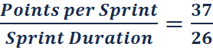 = 1.42 = 1.5 (approx)**

**7. CODING & SOLUTIONING (Explain the features added in the project along with code)**

**7.1 Predicting Uploaded image:**

def upload():

if request.method == 'POST':

*# Get the file from post request*

f = request.files['image']

basepath = os.path.dirname(__file__)

filepath = os.path.join(

basepath, 'uploads', secure_filename(f.filename))

f.save(filepath)

def model_predict(img_path, model):

img = image.load_img(img_path, target_size=(224, 224))

*# Preprocessing the image*

x = image.img_to_array(img)

*# x = np.true_divide(x, 255)*

x = np.expand_dims(x, axis=0)

*# Be careful how your trained model deals with the input*

*# otherwise, it won't make correct prediction!*

x = preprocess_input(x, mode='caffe')

index =['AFRICAN LEOPARD','CARACAL','CHEETAH','CLOUDED LEOPARD','JAGUAR','LIONS','OCELOT','PUMA','SNOW LEOPARD','TIGER']

preds = np.argmax(vgg16.predict(x))

return index[preds]

*# pred =np.argmax(model.predict(x), axis=1)*

*# Make Prediction*

preds = model_predict(filepath, vgg16)

print(preds)

text="The Big cat in the Image is: "+ preds

**7.2 Information about Big Cats:**

<div *class*="loader" *style*="display: none"></div>

<h3>

<span *id*="result"> </span>

</h3>

<details>

<summary><b>Cheetah </b></summary>

<p>

Types: Asiatic Cheetah, South African Cheetah, Northwest

African Cheetah, Acinonyx jubatus raineyii, etc. Different

Species: There is one primary species of cheetah, Acinonyx

jubatus. Habitat: Cheetahs are found in a variety of

habitats including grasslands, savannas, and arid areas.

Endangered: Vulnerable (Not Endangered) Where Found: Mainly

in Africa, with a small population in Iran. Behavior:

Cheetahs are known for their incredible speed and are often

solitary hunters. Main Role: Cheetahs play a key role in

controlling herbivore populations.

</p>

</details>

**8. PERFORMANCE TESTING**

**8.1 Performace Metrics:**

**Achieved 82-95% accuracy**

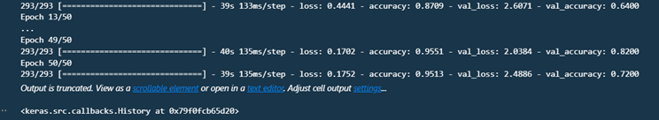

**9. RESULTS**

**9.1 Output Screenshots:**

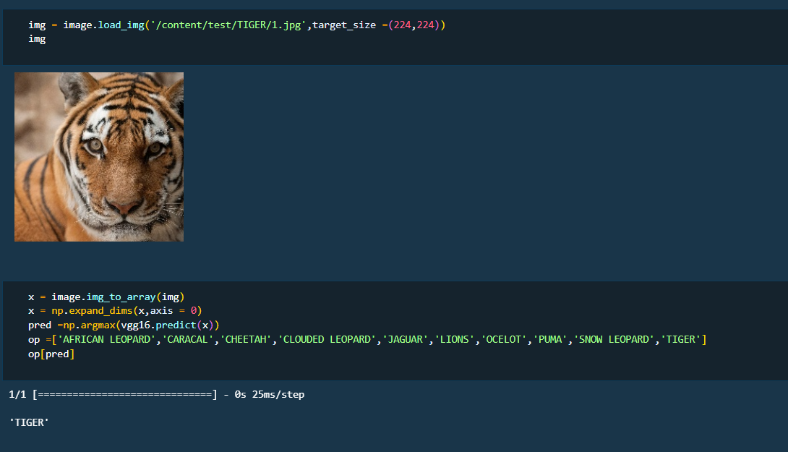

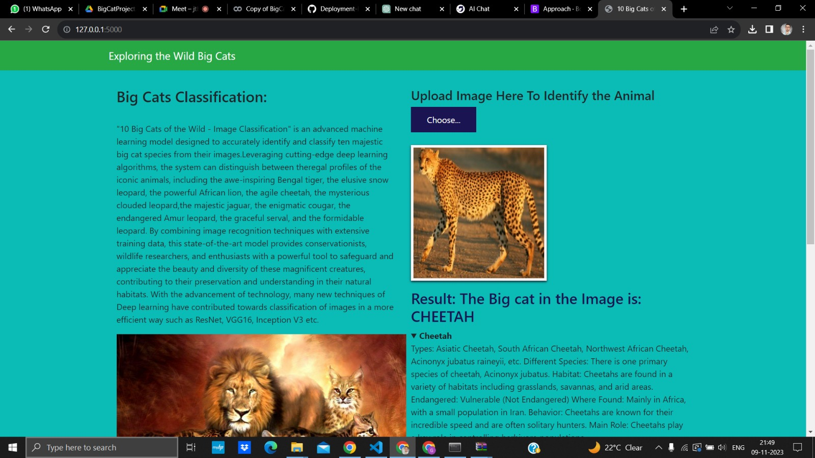

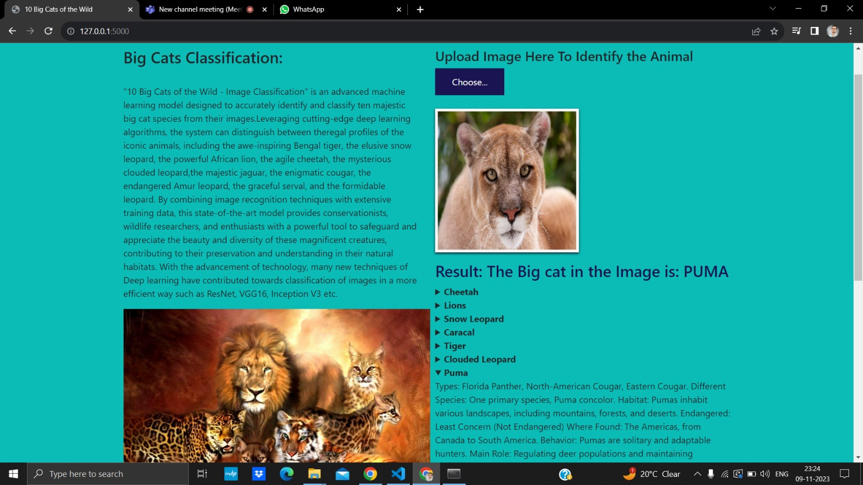

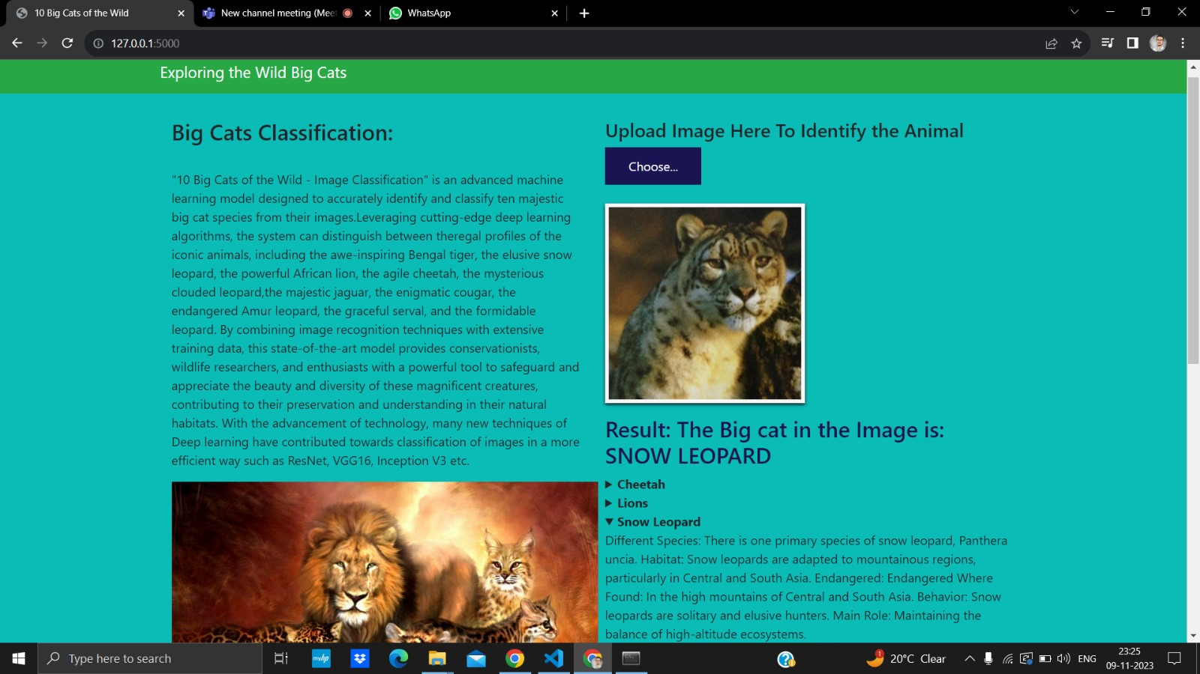

**10. ADVANTAGES & DISADVANTAGES**

**Advantages:**

1. Efficient Species Identification: The AI-powered image classification system can efficiently and accurately identify different species of wild big cats. This is crucial for wildlife researchers, conservationists, and park rangers who need to monitor and protect these species.
2. Conservation Impact: Accurate species identification contributes to better conservation strategies. It allows for targeted efforts to protect specific big cat species and their habitats, ultimately aiding in the conservation of endangered or vulnerable populations.
3. Data Collection for Research: The project facilitates the collection of large datasets of wild big cat images. This data can be valuable for scientific research, helping researchers gain insights into the behavior, distribution, and population dynamics of these species.
4. Wildlife Monitoring: The AI system can be deployed for continuous wildlife monitoring, providing real-time information on the presence and movements of big cat species. This can aid in addressing human-wildlife conflicts and implementing effective management strategies.
5. Enhanced Anti-Poaching Efforts: The technology can be used as part of anti-poaching efforts by identifying and tracking big cat populations. This can help authorities detect and prevent illegal activities, such as poaching, which pose a significant threat to these species.
6. Public Awareness and Education: The project can contribute to public awareness and education about the importance of big cat conservation. By showcasing the technology and its impact, it may inspire public support and involvement in wildlife conservation initiatives.
7. Efficiency in Resource Allocation: With accurate identification, conservation resources can be allocated more efficiently. Funds and efforts can be directed towards specific species or regions that need urgent attention, optimizing conservation outcomes.
8. Technology Advancements: The project represents a technological advancement in the field of wildlife conservation. It demonstrates the potential of AI and image recognition technologies to address complex environmental challenges.
9. Collaboration Opportunities: The project may foster collaboration between technology experts, conservationists, and researchers. Such interdisciplinary collaborations can lead to innovative solutions and a more comprehensive understanding of big cat ecology.
10. Potential for Scaling: If successful, the project can serve as a model for similar initiatives in other regions and for different wildlife species. The technology may be adapted and applied to various conservation contexts globally.
11. Tourism and Eco-friendly Development: The project's success can attract ecotourism and contribute to eco-friendly development. A thriving population of big cats can be a draw for tourists interested in observing these majestic animals in their natural habitats.
12. Positive Economic Impact: Successful wildlife conservation efforts can have positive economic impacts on local communities. Ecotourism, improved ecosystems, and sustainable practices can contribute to the economic well-being of the regions involved.

**Disadvantages:**

1. Accuracy Concerns: The AI system's accuracy in identifying big cat species might not be perfect. Misclassifications or false positives/negatives could occur, leading to incorrect conservation decisions or ineffective management strategies.

2. Bias in Data: If the training data used to develop the AI model is biased, the system may struggle to accurately identify certain subpopulations or species variations. This bias could result in overlooking specific groups of big cats or misinterpreting their behaviors.

3. Limited Generalization: The AI model may be trained on specific datasets, making it less effective in identifying big cat species that it hasn't encountered before. This limitation can reduce the system's applicability to different regions or rare species.

4. Technological Dependence: Overreliance on the AI system could lead to a reduction in human expertise. Conservation efforts should ideally integrate AI technology with the skills and knowledge of experienced wildlife researchers and conservationists.

5. Privacy Concerns: In cases where the project involves monitoring big cat populations using images, there may be concerns related to the privacy of individual animals. Balancing the need for monitoring with ethical considerations is crucial.

6. Financial Costs: Developing and maintaining AI-powered systems can be expensive. The financial burden may limit the scalability and sustainability of the project, especially for organizations with limited resources.

7. Cybersecurity Risks: Any system that relies on technology is vulnerable to cybersecurity threats. Unauthorized access to the AI system's data or algorithms could compromise the project's integrity and effectiveness.

8. Community Resistance: Local communities may be resistant to the implementation of AI technology for wildlife monitoring. Concerns about job displacement (e.g., traditional wildlife trackers) or cultural considerations may lead to resistance.

9. Ecosystem Dynamics Ignored: Focusing solely on big cat species identification may overlook broader ecosystem dynamics. Conservation efforts should consider the interconnected relationships between species and the overall health of ecosystems.

10. Ethical Considerations: The use of AI in wildlife monitoring raises ethical questions, such as the potential for unintended consequences on ecosystems or the ethical treatment of animals. Striking a balance between technological advancements and ethical considerations is crucial.

11. Unintended Consequences: Implementing AI systems in conservation may have unintended consequences, such as changes in animal behavior due to increased human presence or disruptions to natural processes.

**11. CONCLUSION**

"Jungle Detectives: AI-Powered Image Classification of Wild Big Cats" epitomizes the harmony between technology and nature. By embracing the power of artificial intelligence, this project not only elevates our understanding of wildlife but also strengthens our resolve to protect the natural wonders that inhabit our planet's jungles and savannas.

**12. FUTURE SCOPE**

As we move forward, Jungle Detectives aspires to expand its reach, incorporating more species into its classification repertoire. Additionally, collaborations with wildlife organizations and researchers are on the horizon, aiming to leverage our technology for broader ecological studies and wildlife monitoring initiatives.